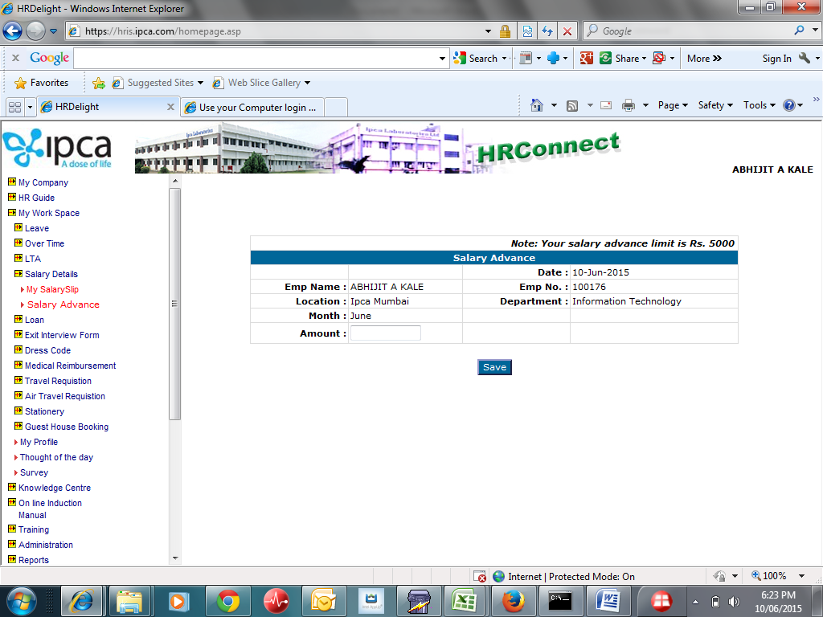

1. Salary Advance Limit needs to be Parameterized in PMS_SETTING_PR_PARAMETERS.
2. Employee can fill Salary Advance between 10th to 16th of the month. ( Dates are to be parameterized).
3. Option required with H.R. designated person to enter Salary Advance on behalf of employee.
4. Amount should not exceed limit if entered by employee.
5. If H.R. is entering on behalf of employee then warning / alert should come if limit is exceeded but should allow. A log should be maintained for such deviation.
6. H.R. will approve each Salary advance.
7. H.R. should be able to see the list of advance requests with selection of company, location and month.
8. List will contain Appl Id, Employee Id, Emp Name, Department Name, Amount.
9. Beside this system should show two links “Show Last Payslip” and “Attendance Details” of the selected employee.
10. If HR decides not to allow any salary advance then “remarks” should be filled by HR.
11. Employee should be able to view “History / Status ” of Salary advance application. Status means Approved by HR, Payment done, Rejected due to …
12. H.R. can edit the amount for correction if any.
13. This will be forwarded to accounts in a specified format. Sr No, Employee Id, Employee Name, Bank Name, Account Number, Amount. Bank name should be in header, i.e. list should be bank wise.
14. Once HR forwards data to accounts, system should not allow user to add any more entries for that month.
15. Salary Advance Employees list report - Save As excel & print option required.
16. Simultaneously this will be added in PMS_PR_TRANSACTION_DETAIL for deduction through same month payroll.